Employee Attrition Prediction – PART A
Objective
In Part A, we have embarked on cleaning the employee data value so that we can prepare it to be used by a monitored model which will know who will leave the company. This was supposed to ensure that nothing is messy, unorganized, or hard to train on as they draw out the big drivers of turnover (Jose, 2021).
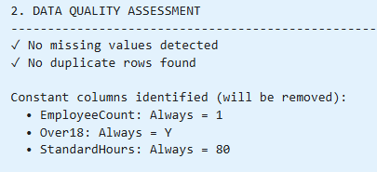
Approach
Our experiment began by viewing 1,470 employees and 35 features. Our target, Attrition, was not able to achieve better than 16.1 percent of the staff- so we knew we were dealing with an unbalanced course. Fortunately we did not have any missing values or duplicated rows, and that was a good thing. We have discarded the superfluous columns such as EmployeeCount, Over18, and StandardHours as well as the ID column EmployeeNumber as these do not contribute to prediction and are informative (Fallucchi et al., 2020).
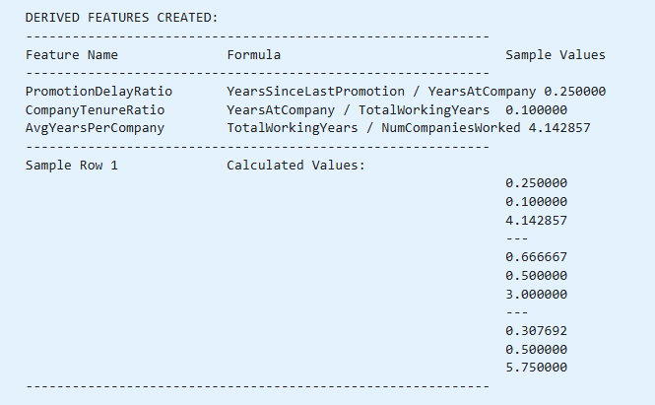
We then characterized the features as nominal, ordinal, continuous, or discrete so as to determine how to preprocess them. To ensure that the minority class was still represented in both sets, we divided the data into 80/20 train test split in a stratified manner. In the case of feature engineering, we designed three ratios namely, PromotionDelayRatio, CompanyTenureRatio, and AvgYearsPerCompany to include career pacing, length of stay, and job stability in general. Labeling the new features served the purpose of exploratory analysis (Patil and Jadhav, 2023).
Key Insights
There is a small rate of attrition, but the asymmetry will require managing in the model. The quitters experience less tenure, slower increases in promotion, and even less job satisfaction. The new ratios show delays in career development and a determination with a long term. Overall, it appears that turnover is correlated with the speed of climbing, the duration of employment, satisfaction, and work-life balance outcomes (Fallucchi et al, 2020). The data is now neat with structure and can be pumped to a model to understand its predictability in terms of attrition.
References
Fallucchi, F., Coladangelo, M., Giuliano, R., & William De Luca, E. (2020). Predicting employee attrition using machine learning techniques. Computers, 9(4), 86.
José, U. (2021). Python programming for data analysis. Springer Nature.
Patil, J. K., & Jadhav, P. M. (2023). Predicting hr churn with python and machine learning. Journal of Advanced Zoology. DOI, 10.

